Comments

- How are you testing this for other browsers? Mike was getting java script errors. I did not. Vjeko was getting java script errors on his computer last week. This may not be a server problem as much as a browser problem. – Not completed

- Overall map – when a map view is showing by default, we need a legend to show what the colors mean. When we looked at the Policy Link maps there was a overlay explaining the maps when someone first got to the page. Should we do that? Discuss with Mike and your team. – Completed

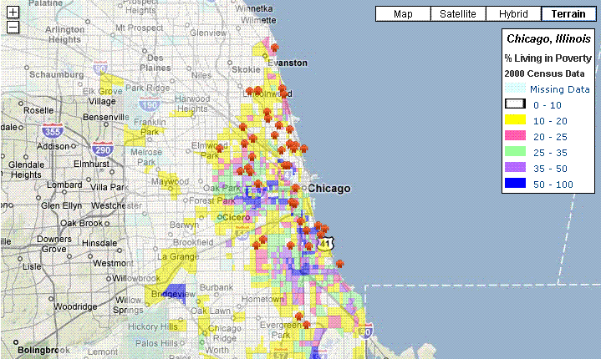

- The boundary you are showing for Chicago seems to be all of Cook County, not just the Chicago city limits. Mike will send shapefile – Removed Cook boundary. There is some issue on Chicago boundary shape file. Latitude and longitude looks different compare to others. We attached the excel sheet for that.

- The icon for programs blends too much with the color of the map. Can you figure out a different color that shows better? The colors used for poverty are too strong. Perhaps use pastel colors. Mike suggests a transparency option within the API (talk to him) – Changed the Program icon and Poverty colors as pastel colors.

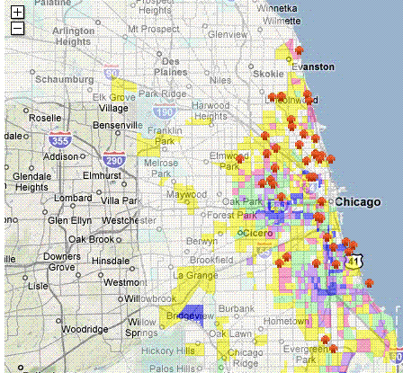

- The opening map view (when site opens) should have a default that shows a) tutor/mentor programs; b) poverty; c) poorly performing schools; d) with Chicago boundary (not Cook County) – Now by default shows Tutor Mentor programs and poverty data. We got the school data yesterday from Mike, loading poorly performing schools data is in progress.

- In the opening map view show the Programs Tab, not the city tab. – Completed

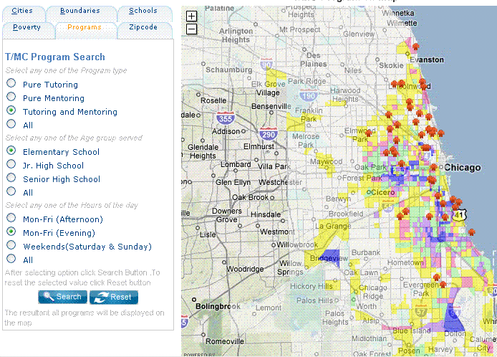

- Re: Schools Tab: On the schools tab I cannot tell if you are showing “all schools” or just “warning list schools” . In your table you repeat 2006 twice. – Completed

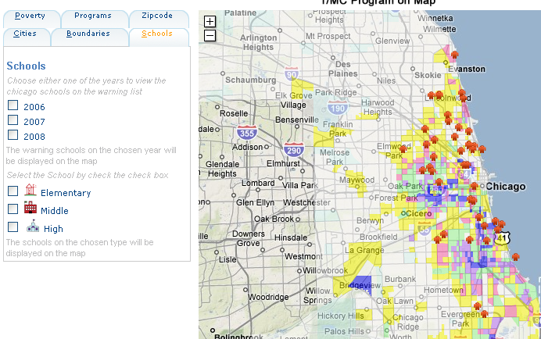

This map needs a bit of clarification. (Talk with Mike to clarify this)
  - instead of showing counties, list the cities we are focusing on, plus Cook County. These should be the only choices. Note that right now the boundary for Cook County is shown. When we click on a different county, the map does not frame that county. It stays with Cook.
  - I’ll give you revised text for the descriptions in the legend. However, right now when you click one grade level for warning schools, it only shows Chicago. When you click DuPage and one of the warning levels, it still only shows Chicago.
  - What I want is that this defaults to the Chicago boundary, and that you can click to one of the 3 or 4 other cities, plus Cook Country, which we feature. When we click one or all three grade levels of schools on warning, we would get those schools for that region. – Removed county information from schools tab. Today we get the list of cities data. That work is in progress

- Re: Zip Code Tab: The 60622 zip code has spit into two zip codes and the new one is 60642 (which is where we are located). Mike will send you the shape file for the new zip codes. – Completed

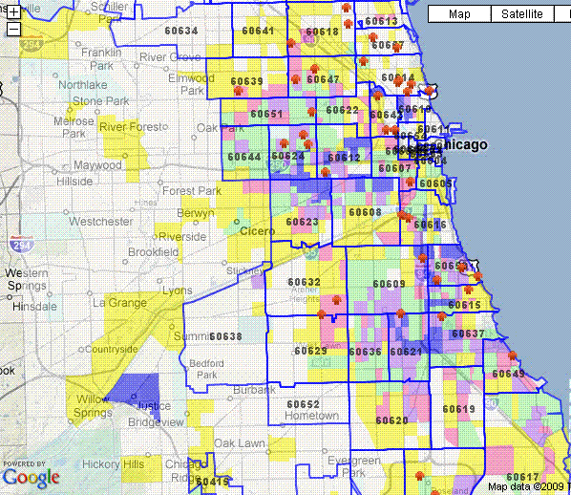

- Re: Zip Code Tab: In the zip code search, when you type in a zip code it should zoom to that zip code the same way it works when you select the zip code from the drop down menu. Once Mike sends you the file, make sure 60642 is on the drop down menu and in the search fields. - Completed

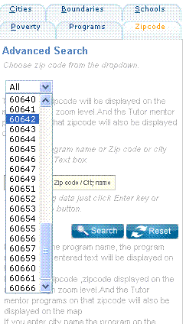
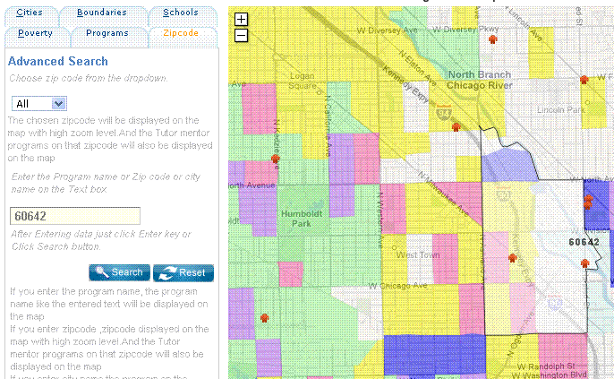

- Re: Boundaries Tab: In the boundaries tab, when I click zip codes, the borders are too thick. However, it is good that each zip code number is included. When I click communities or counties, I need to see names of communities the same as when we see zip codes. – Completed (Style issues for info window pending)

County name shown as
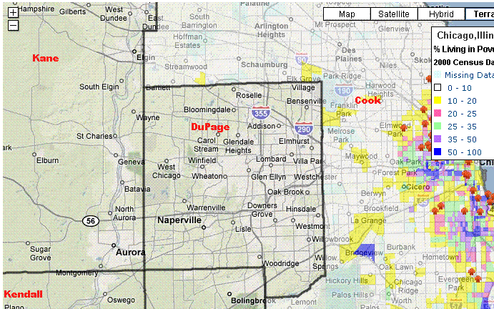

Now we shows the community name by clicking inside community

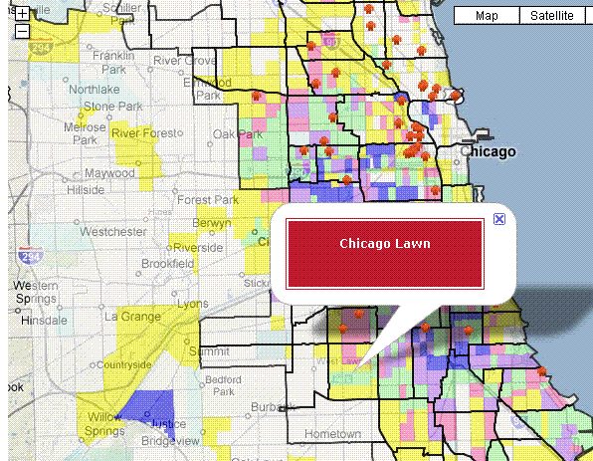

Note. This same issue is present on the District Map. When we look at congressional, senate or house maps, we need to have a label showing what district is which. – Not completed (In the data given we have no district name for each district boundary)

Also, in boundaries, you show a category for “political”. Is this the same as in the District Map? I think that “political” should not be included in this category of boundaries, since we’re featuring this in the district maps. - Completed

- Re: Boundaries Tab Mike will provide poverty information for Aurora, Elgin, Waukegan (we need to add Joliet). Mike will provide boundary for Chicago. – Not completed Required Poverty data for those cities

- Re: Program Tab: In the Program tab, is this limit needed (The resultant top 40 programs will be displayed on the map)? The reason this was on the program locator is that when we searched ALL, it brought up too many programs on the map. Do we need this limit on this Program Locator ?

When we search for “tutor/mentor” or “pure mentor” we should see all the programs for that search, not a limit of 40. – Completed

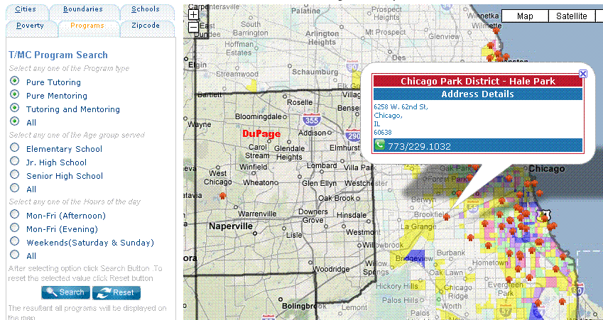

- Re: District map: I think we need a different name. Government map. -Completed

- Re: The District map page: needs to also layout like the asset map page, with three or four boxes representing the different categories we show. On the ledged you need to say “Ill House” and Ill. Senate, so people differentiate between the state legislature and the US Senate – Not completed need skeleton of screen format

- Re: The District map page Re: functionality. When we click on a program, bank, church etc the icon comes up showing who that is. This is good. However, it stays too long, meaning we can’t pop from icon to icon to skim the map and see who is there. Please talk to Mike about this. Maybe you two can find fix. – Completed (Now we removed the pop up window while mouse out from the icon)

- Re: The District map : in the District map, the categories, such as house, should be listed like the “banks” on the interactive version. Thus, I could click a specific district, and get a view of that district (same as the view of zip codes). –Need name of districts to add on drop down

- Re: The rest of the story page should look like the asset page, with feature jpgs of maps we’ve made being visible when the page is first opened up. I’ve attached a version of the power point I sent 12/7 with a new page showing what I have in mind. We need to think of a format that allows vertical and horizontal maps, which could change from time to time, depending on the map-story.

- Not completed need screen structure

- Re asset maps: When we look at assets, we need to have potential to also add churches, hospitals, universities, and build a view with combinations of assets. This is important. Discuss with Mike. – Completed (By showing all the tabs)

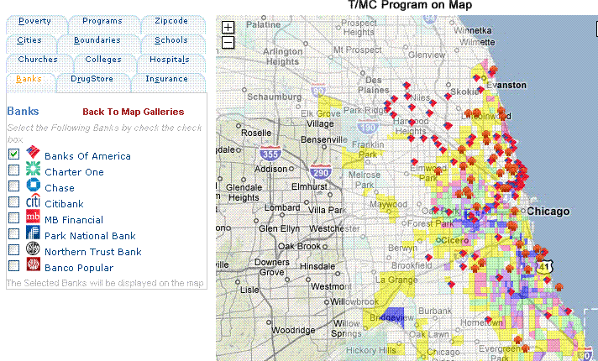

- Re asset maps: when this opens the default should be the city of Chicago, and the default area should center in the map view area. – Not completed
We will show the Chicago boundary after getting .Now we are showing Chicago as center in map view area

- Re asset maps: when we show the interactive map, we want a link to the blog story, opening in a new page. – Not completed

Where we need to add the link and we need the link to be added on the interactive map

